TOP FRAME TIE-DOWN

- PARTS:

QUANTITY: PART #: NOMENCLATURE: LENGTH:

1 PER MACHINE 215004- FRAME, TOP N/A

14 PER MACHINE 46029- TIE-DOWN N/A

14 DROPS PER MACHINE 40011- ADHESIVE, PLASTIC N/A

- ASSEMBLY:

- ATTACH THE TIE-DOWNS TO THE FRAME USING PLASTIC ADHESIVE, ACCORDING TO DIAGRAM 1.

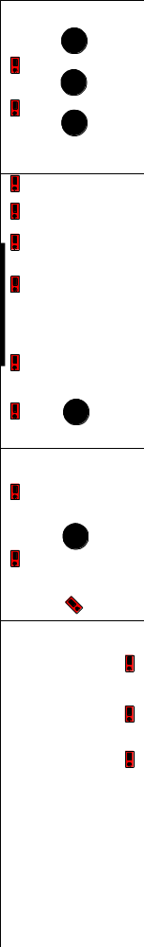

DIAGRAM 1

